**Day-01**

**Date: 25-July-2024**

**Created By: Parth Gurval**

**Assignment 1: Draw your Home Network Topology and explain how you are accessing the RPS Lab environment.**

**Ans:**

* **Home Network Topology:**

* **diagram of home to RPS Network topology:**

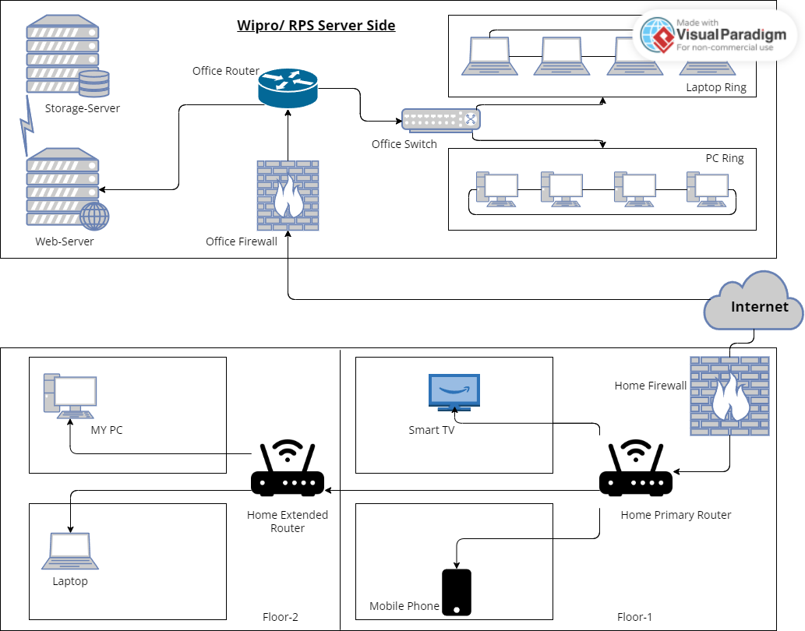

* **Explanation of the Network Components:**

1. **Home Primary Router:** Connects directly to the internet and manages the primary wireless network on the first floor.
2. **Home Firewall:** Provides security by filtering incoming and outgoing traffic between the internet and the home network.
3. **Smart TV:** Connected to the home primary router for streaming services.
4. **Mobile Phone:** Connected to the home primary router on the first floor for internet access.
5. **Home Extended Router:** Extends the wireless network coverage to the second floor.
6. **Laptop:** Connected to the home extended router for internet access on the second floor.
7. **MY PC:** Connected to the home extended router for a stable and high-speed internet connection on the second floor.

* **Office Network Topology:**

1. **Office Router:** Central device connecting the office network to the internet.
2. **Office Firewall:** Protects the office network by controlling the incoming and outgoing network traffic based on security rules.
3. **Office Switch:** Connects multiple devices (PCs and laptops) within the office network.
4. **Laptop Ring:** A group of laptops connected in a ring topology for intra-office communication.
5. **PC Ring:** A group of PCs connected in a ring topology for intra-office communication.
6. **Storage Server:** Dedicated server for storing data and backups.
7. **Web Server:** Hosts web applications and services used within the office network.

* **Accessing the RPS Lab Environment:**
* **To access the RPS Lab environment, I follow these steps:**

**1. Connect to VPN:**

**- Setup:** I use a VPN client provided by the organization to connect to the RPS Lab network securely.

**- Process:** I launch the VPN client, enter the provided credentials, and establish a connection to the RPS Lab network.

**- Outcome:** This allows me to access resources within the RPS Lab environment as if I were physically present on the network.

**2. Access Lab Resources:**

**- Remote Desktop Access:**

**- Setup:** I have a remote desktop client installed on my computer.

**- Process:** I use the client to connect to a remote server in the RPS Lab by entering the server’s IP address and my login credentials.

**- Outcome:** I can interact with the RPS Lab server’s desktop environment remotely.

**- Web Access:**

**- Setup:** I use a web browser to access a specific URL provided by the RPS Lab.

**- Process:** I log in using the credentials provided by the RPS Lab.

**- Outcome:** This provides access to web-based tools and resources within the RPS Lab environment.

**Assignment 2: Identify a real-world application for both parallel computing and networked systems. Explain how these technologies are used and why they are important in that context.**

**Ans:**

* **Real-World Application for Parallel Computing: Autonomous Vehicles**
* **How Parallel Computing is Used:**
  + Autonomous vehicles (self-driving cars) rely on real-time processing of vast amounts of data from various sensors, including cameras, LIDAR, radar, and GPS. Parallel computing is used to process these data streams simultaneously, enabling the vehicle to make quick and accurate decisions.

**Why It’s Important:**

1. **Real-Time Processing**:
   1. Parallel computing allows for the simultaneous processing of sensor data, which is crucial for real-time decision-making.
   2. This enables the vehicle to respond promptly to dynamic driving conditions.
2. **Complex Algorithms**:
   1. Advanced algorithms for object detection, path planning, and motion control can be run in parallel, enhancing the vehicle's ability to navigate safely and efficiently.
3. **Safety and Reliability**:
   1. By processing data quickly and accurately, parallel computing improves the overall safety and reliability of autonomous vehicles, reducing the risk of accidents.

* **Real-World Application for Networked Systems: Online Banking**
* **How Networked Systems are Used:**
  + Online banking systems rely on a network of interconnected servers, databases, and client devices to provide banking services over the internet.
  + This includes account management, fund transfers, bill payments, and customer support.
* **Why It’s Important:**
* **Accessibility**:
  + Networked systems allow customers to access banking services from anywhere in the world, at any time, using various devices like computers, smartphones, and tablets.
* **Security**:
  + These systems implement robust security measures, such as encryption and multi-factor authentication, to protect sensitive financial data and transactions from cyber threats.
* **Scalability**:
  + Networked systems can efficiently handle a large number of simultaneous users and transactions, ensuring reliable service availability and performance during peak times.
* **Integration**:
  + They enable seamless integration with other financial services and platforms, such as mobile payment systems, investment services, and third-party financial apps, enhancing the overall user experience.